OBJECTION TO GRANTING OF RESTAURANT LIQUOR LICENCE TO OREFILE INVESTMENTS (PTY) LTD IN RESPECT OF SHISANYAMA MELVILLE
Application Reference number: GLB7000006178
LODGED BY: -
Full name of objector:
Full address of objector:

Contact telephone number of objector:
Email address of objector:

TO: Liquor Licensing – Johannesburg Regional Office
Gauteng Liquor Board
Matlotlo House
124 Main Street
Johannesburg

Receipt of Objection Acknowledged:

Signed:

Date:

AND TO: Lehlaga Sebake
Applicant’s Representative
11 Reynolds Street
Kensington
Johannesburg
Email: sebakelehlaga@yahoo.com

Receipt of Objection Acknowledged:

Signed:

Date:

- The applicant has applied for a restaurant liquor licence in respect of premises it alleges are situated at 8 Main Road, Melville (Erf 185 Melville) under application reference number GLB7000006178. The application was lodged with the Gauteng Liquor Board on 6 November 2015. The applicant has stated that the application is made in respect of premises which are already erected from which it is operating a restaurant under the name and style of Shisa Nyama. However, a perusal of the facebook page for Shisa Nyama Melville describes its operation as a “Bar|Lounge” and refers to “Sunday Sessions” with a DJ line up. A copy of that page is annexed to this objection, marked “Annexure A”. It is quite clear that it is intending to continue to operate what is in reality a bar lounge with entertainment provided by the DJs under the guise of a restaurant licence. It is submitted that the application should be dismissed for this reason alone as it is an attempt to circumvent the requirements which pertain to pub and tavern liquor licences.

- The application papers made available by the Johannesburg Regional Office of the Gauteng Liquor Board and filed by the applicant for the restaurant liquor licence, Orifile (Orefile ) Investment(PTY)LTD , in terms of section 23 of the Gauteng Liquor Act 2 of 2003 are incomplete or irregular and do not comply with the provisions of that section read with the Regulations made under the Act.

2.1 In particular, no unequivocal approval by the City of Johannesburg of the grant of a liquor licence has been included with the application papers. While this is required only in the case of an application for a pub, tavern or nightclub liquor licence in terms of section 23 (4) of the Act, it is pointed out that the applicant is operating a “bar lounge” with music provided by DJs. It is clear that what the applicant is intending to operate is a pub or tavern, i.e. a business whose primary purpose is to provide alcoholic beverages to its patrons on its premises. No unequivocal approval by the City of Johannesburg has been furnished by the applicant. The document which has been attached to the application ostensibly from the City of Johannesburg’s Department of Development Planning dated 15 July 2015 is clearly a forgery as only a restaurant is permitted on the premises in terms of the current zoning of Business 1 without special consent.

2.2 Furthermore, the names, identity numbers and addresses of every person who has a financial interest in the business and the nature and extent of such financial interests have not been disclosed as is required in the case of a private company applying for a liquor licence in terms of Regulation 2 (1) (b) of the Regulations made under section 141 of the Act read with paragraph 3 (a) of Form 1 in Schedule 2 to the Regulations. All that has been supplied is an affidavit stating that one Edison Chiagozie Abel is a director of the applicant, but no details are provided of his financial interest, and a certificate from the Companies and Intellectual Property Commission which records that the directors of the applicant are the said Edison Chiagozie Abel and one Yaya Longwa. This is of relevance as the applicant is a franchisee in respect of the business, Shisa Nyama Melville, in respect of which the liquor licence is sought, yet it has failed to disclose the details of its relationship with the franchisor, Shisa Nyama. An extract from the website of the franchisor is attached, marked “B”.

2.3 It is also important to establish who has a controlling interest in the applicant, as if such a person is disqualified to hold a liquor licence in terms of section 37 (1) of the Act, a liquor licence cannot be granted to the applicant in terms of section 37 (2). The question (question 2.7) in the liquor licence form submitted by the applicant’s representative as to whether the person contemplated in questions 2.1 to 2.6 has a controlling interest was answered in the negative. It would appear that the person contemplated is Edison Chiagozie Abel which begs the question as to who has a controlling interest in the applicant. Without this information the honourable committee and Board are unable to determine whether they are precluded from granting the licence sought or not and the application can accordingly not be considered.

2.4 In terms of section 40 (1) of the Act a person other than a natural person shall not conduct any business under a licence unless a natural person who permanently resides in the Republic and who is not disqualified in terms of the Act to hold a licence is appointed by such non-natural person to manage and be responsible for its business. It is presumed that the natural person who it is intended will be appointed is Edison Chiagozie Abel as it is stated in the application that he will attend to the daily running of the business yet no clearance certificate by the South African Revenue Services relating to him has been provided. In terms of section 23 (1) (j) such a clearance certificate is required by an applicant without which he is disqualified to hold a licence.

2.5 The applicant has stated that it has the right to occupy the premises in respect of which the liquor licence is sought. The lease agreement which is included in the application papers reflects that it is between Amzu Properties, allegedly the landlord, and Orfile (sic) Investments as the tenant. However, the signature which appear above “LESSOR” in the lease is the same as the signature to the affidavit deposed to by Edison Chiagozie Abel, the erstwhile representative and director of the lessee, nor is the agreement dated. It is also noted that the agreement provides in clause 3.1 that the premises will be used solely for the purposes of “Fast Foods & Liquor outlet Chesa Nyama” yet in clause 7.2 it provides that the lessor consents to the lessee shop fitting the premises so as to establish a “general trading store”. It is doubted that the lease agreement is genuine and the applicant is called upon to provide an affidavit from the registered owner of the property confirming that it does have the right to occupy the premises and use it for a restaurant.

2.6 Moreover the premises referred to in the lease agreement as being the subject of the lease is “a shop on ground floor the premises situated at 5 Main Street Melville”. However, the applicant has stated in its application that the premises in respect of which it is seeking a liquor licence are at 8 Main Road, Melville (erf 185 Melville) in its application. All the references in its application are to erf 185 Melville or 8 Main Road, Melville, including the letter from the City of Johannesburg and the zoning information provided. Indeed 8 Main Road is the street address of erf 185 Melville. However, the Shisa Nyama Melville business is not situated at 8 Main Road (erf 185 Melville); the ground floor shop on this erf is occupied by the “Ocean Basket”. As the applicant has not established its right to occupy the premises to which it refers, the application for a liquor licence in respect of the premises must be refused.

For the above reasons, the application for a restaurant liquor licence falls to be refused.

- It is denied that the premises will be suitable for the purposes to which the applicant is intending to put it. According to the information provided by the applicant in its application, it is envisaged that up to 58 people will be accommodated in the premises at any one time yet only two toilets are provided for woman and one toilet and three single urinals for men. This is woefully inadequate for the type of operation that the applicant envisages.

- It is clear that “entertainment” is and will be provided. As mentioned the business’s own Facebook page makes this quite plain. Moreover it is clear that a bona fide restaurant will not be provided as is required in terms of sections 54 and 55 of the Act, nor does the applicant give any undertaking that patrons will only be served liquor immediately before, with or immediately after their meals.

- A further problem with the suitability of the premises is that nothing is said in regard to the provision of parking for patrons on the premises. The lease agreement makes no provision for parking whatsoever. This will result in patrons’ motor vehicles causing considerable congestion in the adjacent streets and in particular, on Main Road from which patrons access the applicant’s business. Main Road is a major arterial road and carries a great volume of traffic. There is a considerable risk that patrons will spill out from the premises onto the pavement and into Main Road creating a hazardous situation not only for themselves but also for passing pedestrians and motorists. It is noted that the town planning regulations require that parking be provided yet the applicant has not dealt with this issue at all.

- Melville is a primarily residential area with two strip business/commercial areas on 7th Street and Main Road. The business/commercial strips were created to allow for the establishment of retail outlets and facilities to serve the Melville residential area. The Main Road area and its vicinity were not designed or laid out in order to carry numbers of restaurants, pubs and night clubs. As a consequence of this residentially-based layout, the Main Road business/commercial strip is very narrow, typically consisting of a depth of only one erf from the Main Road. Indeed the properties on Second and Third Avenues immediately behind the erf on which the applicant’s premises is situated, are single dwelling residential properties as are all the remaining properties on Second and Third Avenues as one moves westwards up to Second Street Melville. On the opposite side of the Main Road the vast majority of the properties situated on the block bounded by Main Road, Third Avenue, Third Street and Second Avenue, are single dwelling residential properties. The type of activity which is likely to take place in and around the applicant’s premises should it obtain a liquor licence, which will raise noise levels, cause street congestion and result in an increase in antisocial behaviour will have a directly negative impact on the quality of life enjoyed by these residents.

- Furthermore, the area is already more than adequately served by similar licensed establishments. Catz Pyjamas, which is open until 2am, is on the other side of the Main Road diagonally opposite the premises of the applicant (40m away) and Stones, which is open until 4am, is immediately adjacent to the applicant, one floor above it. Across Main Road (32m away) is the Tsunami Bar and Restaurant which in breach of its restaurant liquor licence is operating as a pub and nightclub despite its licence having only been granted less than a month ago in the face of much opposition from the residents. Stones has been a problem business for a considerable period, causing much disturbance to the surrounding residents because of the noise its activities generate and the behaviour of its often unruly patrons. Indeed proceedings have been brought against Stones for breaching the conditions of its licence which are currently being dealt with by the Liquor Board. These businesses attract drug-dealers to the area and there have been incidents in which alcohol and drug enflamed patrons have used Main Road as a drag-racing strip. There are two other drinking establishments in Main Road which attract unsavoury elements and vagrants, the most notorious being Paul’s Tavern. Beneath Catz Pyjamas there is also a Liquor City Store with an off-consumption licence. In the Campus Square Shopping Centre which is about 470m from the premises and closer to the University of Johannesburg, there is a News Café, a Dros and a Rocomama’s which because of their location in a shopping centre are better managed and controlled and better situated in that there is a considerable buffer between them and the closest residential properties. Accordingly there is no need for another similar establishment and the grant of yet another on consumption liquor licence in the Melville area would not be in the public interest.

- There are two educational institutions within 500m of the premises, Melpark Primary and the Sparrow Foundation School. Indeed, Melpark Primary is situated in Third Avenue, a block from the premises. There are bus stops for the bus and the Rea Vaya in Main Road within 100m of the premises. There is a very real possibility that drunken patrons of the applicant’s business could interfere with and interact in an undesirable manner with the children from the two schools. Patrons spilling out onto the pavement and the Main Road could also interfere with the operation of the Rea Vaya feeders which run along Main Road past the applicant’s premises. There are also several churches within 500m of the premises, including the Rivonia Seventh Day Adventist Church, the Potters’ Church, the Kruisgemeente Church, the Methodist Church and the Christ Embassy Church.

- As far as the question of the applicant’s character is concerned and whether it is fit to hold the licence sought by it, despite an internet search very little information could be found which suggests that the applicant has not been trading. Accordingly, the fact that it has a tax clearance means nothing. However, it is reiterated that the director of the applicant who it seems will manage the business has not provided a tax clearance certificate. It is not conceded that he is of good character or that he or the applicants are fit to be the holders of the licence.

- As the applicant has failed to disclose who has financial or controlling interests in the business, it is not possible to assess whether a monopolistic condition may arise or be aggravated. It is not conceded that the possibility does not exist that the granting of the application may cause a harmful monopolistic condition to arise or be aggravated.

- The inadequate provision of toilets and the failure to deal with the issue of parking have already been highlighted. No or scant details are provided in the application papers of fire-proofing and soundproofing. The kitchen area also appears to be woefully inadequate to cater for 58 potential patrons demanding restaurant meals. As far as other environmental and safety requirements are concerned no detail is provided. Accordingly it is denied that the premises, equipment and facilities are in compliance with the Act and regulations.

- As far as the provisions of section 30 (3) are concerned, as has been pointed out, there are places of worship, educational institutions, similar licensed premises and public transport facilities within 500m of the applicant’s premises. This is a problem which has been highlighted by the Gauteng Province in the Gauteng Liquor Policy drafted in 2011:

“Proximity of licensed premises to public facilities
There are many licensed premises which are located
within a 500 metre radius of places of worship,
educational institutions, similar licensed premises or
public transport facilities in contravention of existing
legislation. Many of these premises are generally
located in residential areas or are premises licensed
in terms of the Liquor Act, 1989. The result of the
location of premises near schools and places of
worship is that:
• under-age persons have easy access to
liquor;
• intoxicated patrons victimise learners and
educators and members of the community;
• the activities within these premises and the
noise and entertainment interferes with the
activities at educational institutions and can be
a nuisance to residents living in their vicinity;
• These premises and their patrons operate for
at least 16 hours a day, creating continuous
noise and pollution for surrounding residents;
and
• These premises often have patrons who are
involved in fights with each other after alcohol
consumption or fights with other people as
they leave the drinking premises.”
- It was recommended in the policy document that the following approach should be adopted in regard to the issue of liquor licences:
“Within the broad context of the above-mentioned
spatial planning principles the need and desirability
of a proposed liquor license should be considered in
relation to:
• limiting of land uses in residential areas
that negatively impact on the amenity and
character of an area;
• the agglomeration of potentially disturbing
land uses;
• the development of buffers around residential
areas to minimise the effect of potentially
disturbing land uses; and
• the advancement of public participation.
Specific consideration should be given to potential
influence of:
• Noise generation;
• Impact on the privacy of surrounding owners;
• Provision of parking and traffic impact
pertaining to deliveries;
• Safety issues as per the National Building
Regulations; and
• Health Regulations.

The application of these principles leads with respect to the conclusion that the application for a restaurant liquor licence should be refused. The Honourable members are accordingly respectfully requested to refuse the application.

Signed: --------------------------------------
Date:

Full names of Objector:

Address of Objector:

Contact telephone number of Objector:

Email address of Objector:

ANNEXURE “A”

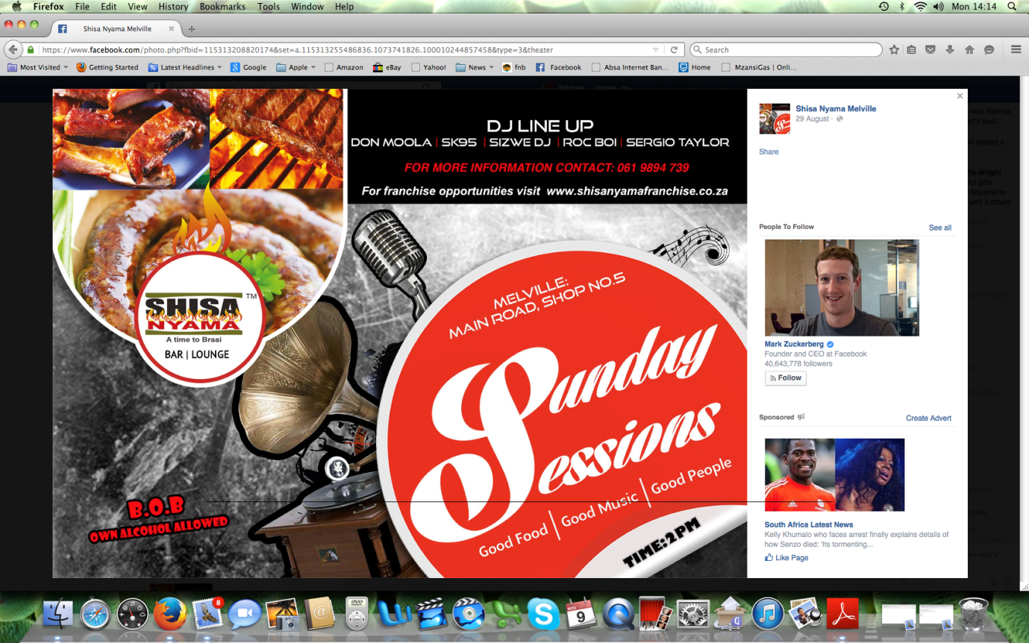

ANNEXURE “B”
