OBJECTION TO GRANTING OF RESTAURANT LIQUOR LICENCE FOR NCW RESTAURANTS AND RESIDENCES (PTY) LTD IN RESPECT OF PREMISES SITUATED AT 46 MAIN ROAD MELVILLE (BOUNDED BY 10th AND 11th AVENUE MELVILLE, ERF NUMBER 879
Application Reference number: GLB 7000008218
LODGED BY: -
Full name of objector: MELVILLE RESIDENTS ASSOCIATION
Full address of objector: 126a 4th AVENUE, MELVILLE 2092
Contact telephone number of objector: 0833757742
Email address of objector: mra-liquor@ilovemelville.co.za

TO: Liquor Licensing – Johannesburg Regional Office
Gauteng Liquor Board
Matlotlo House
124 Main Street
Johannesburg

Receipt of Objection Acknowledged:
Signed:
Date:

AND TO: J G A Steenkamp
Exclusive Liquor Consultants and Architectural Designers cc
(Member of the Liquor Licencing Consortium of South Africa)
Applicant’s Representative
PO Box 23170
Helderkruin
1733

Email: hannes.s@webafrica.org.za

Receipt of Objection Acknowledged:
Signed:
Date:

The applicant:
(1) NCW RESTAURANTS AND RESIDENCES (PTY) LTD, REGISTRATION NUMBER 2015/111467/07 POSTAL ADDRESS C/O EXCLUSIVE LIQUOR CONSULTANTS, P O BOX 23170 HELDERKRUIN 1733 (2) NICHOLAAS CASPARUS WILLEMSE, ID NUMBER 881220 5233 083, Director, Postal address: P O Box 1010 Fonteinriet Boksburg, Gauteng 1460, Residential: 92 Peeka Street Stellenbosch, Western Cape 7600. 100% of the shareholders interest in NCW RESTAURANTS AND RESIDENCES (PTY) LTD has applied for a restaurant liquor licence in respect of NCW RESTAURANTS AND RESIDENCES (PTY) LTD at 46 Main Road (Bounded by 10th avenue and 11th avenue Melville Johannesburg Erf number 879), under application reference number GLB7000008218.

The Melville Residents Association (“MRA”) has had sight of the application papers made available by the Johannesburg Regional Office of the Gauteng Liquor Board as filed by the applicant for the above premises in terms of section 23(1) the Gauteng Liquor Act 2 of 2003. Certain aspects relating to this application are of particular concern to the MRA and have led to it filing this objection.

BACKGROUND

i. From 1978 to 1994 there was a 150% increase in the per capita consumption of alcoholic beverages in South Africa, which now has one of the highest levels of alcohol consumption per drinker anywhere in the world.
ii. The manufacture, marketing and sale of liquor has recently received much attention from local, provincial and national government structures, as well as from communities and stakeholders in the liquor industry.
iii. The Gauteng MEC for Economic Development Lebogang Maile recently stated that, “the board must endeavor to limit the negative impact of liquor outlets in residential areas”
iv. The Minister of Trade and Industry stressed the concerns regarding alcohol usage in South Africa during his media briefing at the release of the National Liquor Amendment Bill.
“According to Minister Davies, South Africa currently has the highest level of alcohol consumption in the world at 10-12% as compared to the world average of 6%.
“‘We are also the highest with regards to the Foetal Alcohol Syndrome in the world, and 41% of the injuries are from incidences related to alcohol consumption,’ adds Davies.
“He also said that the state spends about R3.7 billion per annum on problems related to alcohol abuse.”
[http://www.gov.za/speeches/minister-rob-davies-releases-national-liquor-amendment-bill-public-comment-3-oct-2016-0000]

v. SANCA came out in support of the proposal to raise the legal drinking age to 21, stating the following:
“SANCA supports any initiative to reduce harms and delay the onset of any substance use due to the impact these chemicals such as alcohol has on the developing brain and other risk factors related to adolescents and young people.
“SANCA warns that alcohol is the drug of choice among youth. Many young people are experiencing the consequences of drinking too much, at too early an age. As a result, underage drinking is becoming a leading public health problem in this country.
“Substance abuse is a national concern as indicated by the United Nations World Drug Report in 2014. 7, 06% of the South African population is abusing narcotics and it’s estimated that 1 out of 14 people are regular users of a substance translating to 3, 74 million people.
“…The age group between 13 and 20 years are at high risk of substance use and abuse as reported in the latest SACENDU statistics (February 2016). The 2nd South African National Risk Behaviour Survey (2008 published 2010) reported that one out of two high school learners (49,6%) have drank alcohol and had their first drink before the age of 13 years of age. It further identified that mainly male grade 11 learners are involved in more excessive alcohol use with the highest number in Western Cape (71%) and in Gauteng (65,1%) over the national average of 49,6 %. It was concerning that 28,5% of these learners are involved in binge drinking and drink more than one day a week. These learners (12,7%) reported that they drank alcohol on the school premises.
“Research also shows that many adolescents start to drink at very young ages and that the younger children and adolescents are when they start to drink, the more likely they will be to engage in behaviours that harm themselves and others. For example, frequent dinge drinkers are more likely to engage in risky behaviours, including using other drugs such as marijuana and cocaine, having sex with multiple partners, and earning lower grades in school.
“Today, the average age where young people start drinking for a girl is 13 and for a boy is 11. Underage drinking is a widespread problem with often serious consequences. Young people who drink are more likely to be the victims of violent crime, to be involved in alcohol-related traffic accidents, and to have depression and anxiety. Other risky behaviours are also linked to early drinking. Young people who start using alcohol before age 21 are more likely to:
- Be involved in violent behaviours
- Attempt suicide
- Engage in unprotected sec or have multiple sex partners
- Develop alcohol problems in later life
[http://www.sancanational.info]
vi. The Control of Marketing of Alcoholic Beverages Bill was approved by cabinet on 18 September 2013. The motivation for the bill, according to the Inter-Ministerial Committee on Combating Alcohol and Substance is because “alcohol is reported to rank third on the list of risk factors leading to death and disability while other statistics point to a strong link between alcohol consumption and violent deaths, including those resulting from domestic conflict and suicide. In addition, significant numbers of people arrested for robbery, assault, rape and weapons-related offences are under the influence of alcohol”.
vii. It is against the above background that applications for liquor licences are to be considered.

Liquor trading and consumption in Melville have had a considerable impact on our suburb. While Melville has two strip business / commercial areas on 7th Street leading into 4th Avenue and Main Road, Melville, it is a primarily residential area. The business / commercial strips were created to allow for the establishment of retail outlets and facilities to serve the Melville residential area. As a consequence of this residentially-based layout, the business / commercial strips are very narrow, typically consisting of a depth of only one erf from Main Road, 7th Street and all the avenues from 1st to 5th Street. There is a concern that the type of activity which is likely to take place in and around the applicant’s premises should it obtain a liquor licence, will raise noise levels with a potentially negative impact on the quality of life enjoyed by residents who live within earshot of the premises.

1. In this matter, the application for the licence for NCW relates to 46 Main Road allegedly bounded by 10th Avenue and 11th Avenue which does not fall in the part of Melville that is earmarked in the existing RSDF, for business purposes. This section of Main road has been historically, and remains, a residential node, with limited allowances for certain home enterprises and home offices, which may act as a buffer between the non-residential (UJ sports fields) and the residential area.
This part of the residential node is particularly quiet and peaceful due to the non-existence of potentially disruptive businesses such as restaurants and events venues (we pause to mention that there are already advertisements published, in respect of which the premises is available for end of year functions).

2. These types of venues attract crime – the 7th Street business / commercial strip historically experienced many incidents of lawlessness and serious crime, including drug peddling, muggings, fights, intimidation and harassment of residents, and at least two violent deaths at premises trading in liquor over the past 2 years. In respect of Main Road, the most recent episode of a serious crime was on the weekend of the 12 November 2016 where persons were drinking and allegedly fighting in Main Road using crowbars. Another concern is that there is an illegal commune operating from the corner of 9th Avenue and Main Road, and despite complaints lodged by the residents of that area with the relevant authority this has not been addressed to date. These activities do affect the residents and may well affect the patrons of NCW, e.g. begging outside the restaurant and even opportunistic crime. Littering is also a problem.

3. There is also concern that Main Road Melville is one of the primary roads dealing heavy traffic at times from North to South and vice versa. The traffic control regarding speeding and other road offences is not monitored regularly. Refer below a photo of a serious accident in Main Road this past weekend and in front of NCW premises.

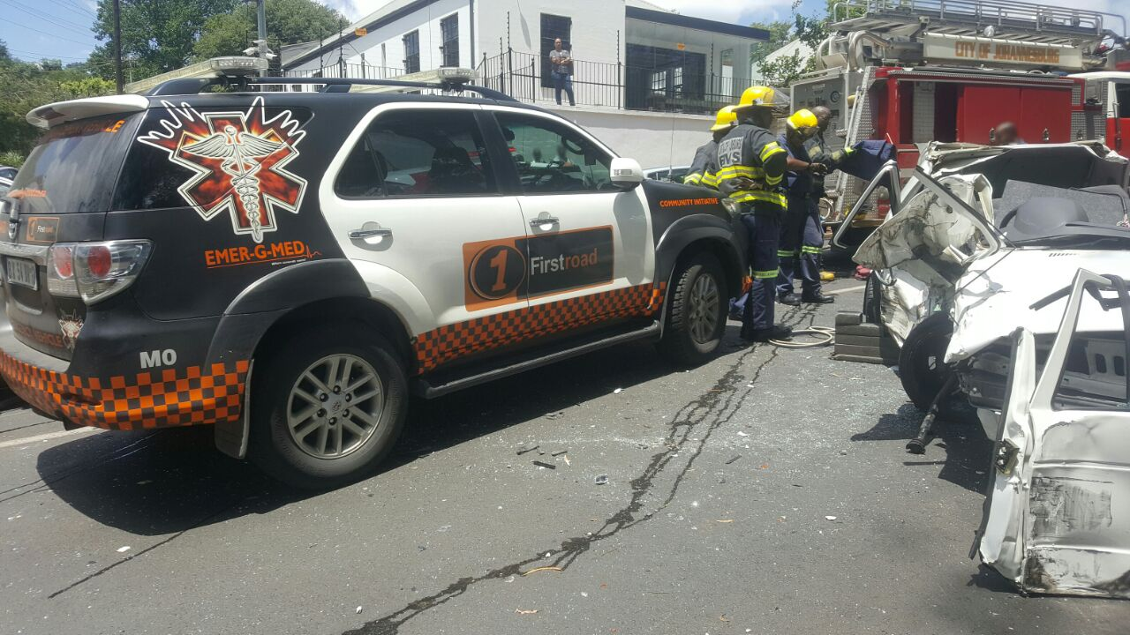

4. There is already an oversaturation of restaurants; cocktail bars; etc. in Melville - all serving liquor with meals and in some instances separately at the bar, both during the week and over weekends. At last count there are approximately 30 liquor outlets in Melville. We now have an application for a restaurant at 46 Main Road Melville and the major concern is the infringement into a primary residential area up 11th Avenue. The concern here is that if this application is successful it will open the door to further such type of applications which will result in further penetration of the residential area. This is likely to result in property values dropping and changing the make-up of residents and restaurants and like businesses in the area between 11th Avenue and 5th Avenue.
5. Parking is already a major problem in Melville especially in the business / commercial nodes, e.g. 7th Street and while we accept that the NCW has provided what appears to be sufficient parking for the patrons of the NCW, it seems to be mainly on the adjacent Erf 878, which does not belong to the applicant. There is no guarantees given in this regard and this fact is not mentioned in the application. Neither can it be guaranteed that patrons will not park in either 10th and 11th Avenues. Cars parked in the street will attract car guards, vagrants, beggars and criminals, including car thieves and drug peddlers. This will raise the incidence of quarrels and fights, rubbish and broken glass, public urination and defecation, and intimidation of residents and patrons alike. This prediction is by no means far-fetched, as this is precisely what has occurred in the business area of 7th street and 4th avenue. The peace, quiet and relative security which most property owners and residents enjoy in the area will be severely compromised.
It is furthermore important to note that this adjacent property, Erf 878, situated at the corner of 10th avenue and Main Road, although on paper owned by a different entity, is, (just as the property which is the subject of the present application) essentially run and controlled by the same persons. Such adjacent property is presently being unlawfully utilized for a large scale catering operation, in open contravention of the present zoning restrictions. The wall between the properties has been removed, and they appear to be run as one property, even though the properties have never been consolidated.
6. The building plans for both the mentioned properties are as yet not approved – this despite the fact that both properties were extensively altered and renovated some time ago. The applicants simply chose to go ahead with major alterations without the necessary approvals. This is further evidence of the applicants’ cavalier attitude toward the law, and suggests that the applicant may be inclined to ignore any and all legal requirements wherever possible and wherever convenient, into the future.
7. The MRA also finds it unacceptable that increased traffic will be experienced in thee two avenues leading to the NCW and the effect it has on the private residences and residents, especially young families. There will also be traffic until the late hours and to and fro from Main Road or subsidiary roads that lead to the NCW. This and the opening and closing of the security gates for patrons and deliveries in the early mornings and late evenings (to the illegal operations on Erf 878) has already and will have an effect on the residents in terms of noise and additional traffic. No amount of noise controlling barriers or noise insulation will prevent the creation of the above nuisances and disturbances, and the peace and convenience of residents will be destroyed. Has there been a traffic study to determine the effect heavy traffic will have on the condition of the roads in 10th and 11th Avenues?
8. Of further grave concern is the fact that the property is directly adjacent to the Melville Koppies Nature Reserve, which is a world renowned nature conservation and archaeological site, and is a sanctuary for a wide variety of rare and protected flora and fauna. The incidence of car guards, vagrants and beggars at the perimeter of the Melville Koppies is likely to lead to rubbish being dumped there, people breaching the fence to sleep on the koppies, and the koppies being used for toilet facilities. The fragile ecology of the koppies stands to be destroyed. In addition, the restaurant would necessarily be required to lay poisons for the rats and other vermin that would otherwise infest the premises. The presence of poisoned rodents would gravely endanger the owls, genets and mongoose that inhabit the koppies.
9. The MRA recently conducted a suburb-wide survey regarding, inter alia, the issue of liquor trading premises in Melville and more particularly at the 27 Boxes Centre close by. It was clearly evident among the survey that there is a significant concern among residents regarding the number of liquor trading premises in the area.
10. Regulation 3(2) d) of the Gauteng Liquor Act provides, inter alia, that:

“(2) An application for a licence as contemplated in section 19 of the Act must be
d) accompanied by a comprehensive written motivation in support of the application which must include public interest requirements–
(i) the need for a liquor outlet in the area,
(ii) the impact of a liquor outlet in the area

(vi) the proximity of other liquor outlets, educational institutions, places of worship and public transport facilities”

The MRA does not believe that the present application adequately addresses the above requirements. Argument will be advanced at the hearing on this point.

11. The MRA is of the view that no live music, nor background music, should be directed from the applicant’s proposed premises into the area surrounding them. All forms of loud music provided for the purpose of entertainment including dancing, must be strictly prohibited in a residential area of this nature. No reference was made to music at the premises and this should have been addressed.

12. In terms of a Liquor Licence, restaurants may serve liquor with meals between 10 0am and 2 am. The MRA notes that the applicant has indicated its intended hours of operation as 7 am to 2 am 7 days a week with no indication of the hours that liquor will be served. This also requires the honourable board’s consideration in reviewing this application.

13. As far as the provisions of section 30 (3) of the Gauteng Liquor Act, 2003 are concerned, as has been pointed out in the application, there are places of worship, educational institutions, similar licensed premises and public transport facilities within 500m of the applicant’s premises. The MRA believes that such details as provided in the application are incomplete and inaccurate. Argument on this aspect will be made at the hearing.

14. Another cause for concern is the fact that section 104 of the Gauteng Liquor Act, 2003 permits a liquor licence, once granted, to be transferrable to another licensee without any notice to the community. This is unacceptable to the MRA as no opportunity is provided to the community to object to the proposed transferee or to the transfer in those instances in which there have been problems caused by the activities of the business which have impacted negatively on the surrounding neighbourhood. Unless it is included as a condition to the grant of the liquor licence (in the unlikely event of one being granted in this instance) that the liquor licence is not transferable to another person and that any change in the current shareholding of the applicant will result in the immediate rescission of the licence, no protection will be afforded to the community to prevent a transfer of ownership and control without its knowledge and the community will have no opportunity to object and raise its concerns.

15. The Regulations furthermore stipulate that the Board must grant a liquor licence subject to specific and general conditions, and that “The Board may add such other conditions as it may deem appropriate in the public interest” – Regulation 13.

16. The MRA wishes to make the following averments in response to certain statements made in the applicant’s written representations:

15.1. The applicant states that there is “more than enough demand” for a facility such as this. There is in fact already more than enough supply of these types of establishments in the area, as is evident from the application papers. Further argument on this point will be advanced at the hearing.

17. The MRA is of the respectful view that the applicant has neither proven the need, nor the desirability or appropriateness of establishing yet another liquor serving establishment in Melville.

18. At this stage there is a request to rezone the property from a “Residential 1” to a “Special”. The MRA and great number of residents have objected to this rezoning and therefore, at this stage no application for a liquor licence can be considered until the rezoning application and objections have be resolved.

19. Please also note that the NCW is already operating as a restaurant, it has a stock of alcoholic beverages but it is not clear that the NCW is already serving alcohol, which would be in breach of the Liquor Act and needs clarification.

20. The MRA works proactively for a safe, peaceful suburb, and is gravely concerned about this trend, especially its negative impact on the rights of individual residents and the far reaching reputational and security compromises it has caused our community.

In conclusion, the MRA is of the respectful view that the establishment of a restaurant in this part of the residential node was an ill-conceived and ill advised idea, and that the application for a restaurant liquor licence should, in light of the above, as well as any further grounds or information which may become available, (and which the MRA reserves the right to raise at the hearing) be refused.

Signed: --------------------------------------
Date:

Full names of Objector: Melville Residents Association
Address of Objector: 126a 4th Avenue MELVILLE 2092

Contact telephone number of Objector: 0833757742
Email address of Objector: mra-liquor@ilovemelville.co.za

