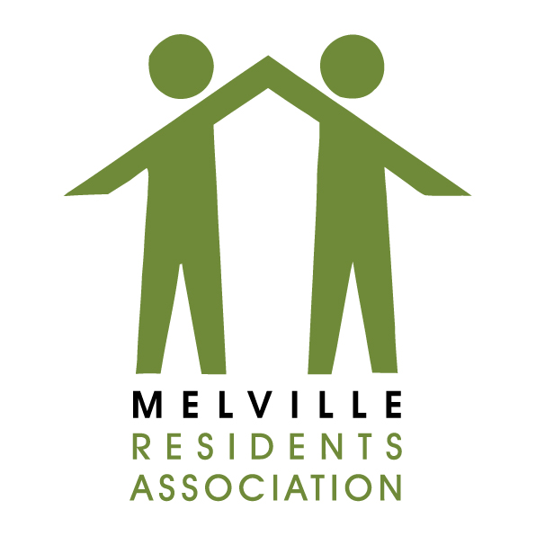

Form 19
Gauteng Liquor Board
Complaint against Licenced Premises

TO:

Gauteng Liquor Board/Inspectorate
Liquor Licencing – Johannesburg Regional Office
Gauteng Liquor Board
Matlotlo House, 124 Main Street, Johannesburg

Palesa Makhabane palesa.makhabane@gauteng.gov.za
Cleo Bodibe-Lushabe cleo.bodibe-lushabe@gauteng.gov.za
Molefi Mothoane molefi.mothoane@gauteng.gov.za
Raymond Martin raymond.martin@gauteng.gov.za

CC:
Melville Residents’ Association
Liquor Portfolio sub-committee
Email Address: mra-liquor@ilovemelville.co.za

Ward Councillor Bridget Steer – bridget.steer@gmail.com

It is not mandatory that you give information about yourself, you may remain anonymous. If you do give personal information, it will remain confidential.

1.1 Full name (Natural or juristic person)

1.2 Physical Address

1.3 Telephone number(s)
Mobile: | Landline:

1.4 Fax number and email address
Fax No: | Email:

2 Information about the licenced/unlicenced premises
2.1 Trading Name

2.2 Physical Address

3 Details of complaint
3.1 Nature of the complaint (Check all that need to that needs to apply)
 | Disorderly behaviour |  | Drug Activities |  | Sales beyond trading hours
 | Sale to minors |  | Sale to obviously intoxicated persons |  | Excessive Noise
 | Other

3.2 Date of Incident: ______________________

3.3 Time of Incident: ______________________

3.3 Have you filed this complaint with another law enforcement agency?
Yes | No

If you answer Yes, please provide details:

Complainants Signature: ____________________________
Date: _____________________

