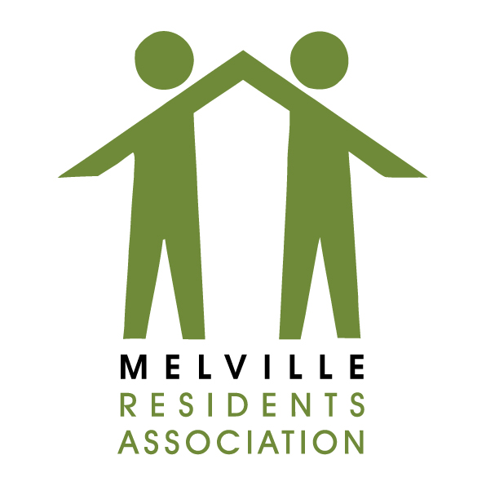

City of Johannesburg
Attention: Mr Joseph Geduld

[Joseph Geduld JosephG@joburg.org.za; THEODORA MDOLOMBA TheodoraMd@joburg.org.za; Theo Tempele TheoT@joburg.org.za]

Complaint regarding Land Use: Property Description (Erf No. (if available) and Street address)

I am writing to you to report an unlawful land use.
The premises are in a building situated at the XXXXXXX Road / Street / Avenue in Melville zoned for business purposes. However, the premises is being used to run live entertainment without the required consent.
These activities commenced during November / December 2018 and continue unabated, especially now with the start of the academic year at the nearby tertiary institutions despite the JMPD visiting regularly.
Here is the Facebook link to the business XXXXXXXXXXXXXXX Melville:
https://www.facebook.com/XXXXXXXXXX
According to the Facebook page / Instagram music is provided and there are DJs supporting the events.
These continue into the early morning hours blasting music over the neighbourhood where residents are trying to rest to be able to go to work for a productive day and this is becoming impossible.

Here are the JMPD reference numbers of recent reports:
XX February 2019 XXX
XX February 2019 XXX
XX February 2019 XXX (no reaction to earlier report)
XX February 2019 XXX

During the prior months I liaised personally with both the owner as well as the manager with no positive results.
Ward Councillor Bridget Steer personally requested that the JMPD go to the premises during the past week also with support from MMC Michael Sun.
Ward Councillor Bridget Steer advised me to contact you regarding escalation of this matter.
I copy the Councillor as well as the Landuse Committee of the Melville Residents Association who is also aware of this problem and communicated with the authorities as well.
Your urgent intervention is required in this matter. Kindly confirm receipt of this communication by email.

Thank you in anticipation.

Yours faithfully,

______________________
Sign
_______________________
Date

mra-landuse@ilovemelville.co.za
bridget.steer@gmail.com

