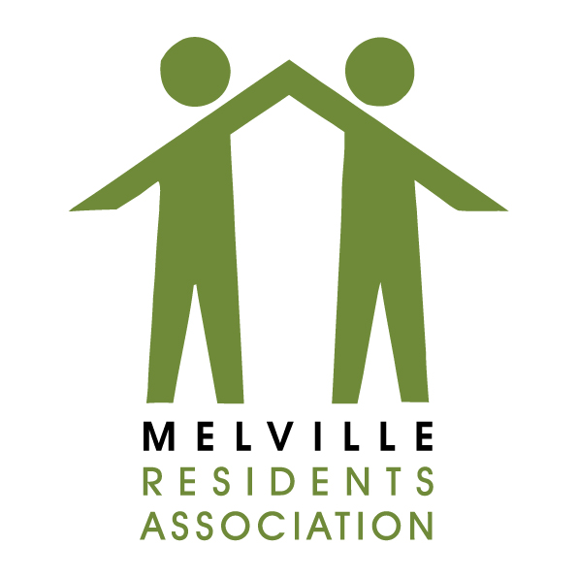

Form 19
Gauteng Liquor Board
Complaint against Licenced Premises

TO:

Gauteng Liquor Board/Inspectorate
Liquor Licencing – Johannesburg Regional Office
Gauteng Liquor Board
Matlotlo House, 124 Main Street, Johannesburg

Mbongeni Shabangu mbongeni.shabangu@gauteng.gov.za
Palesa Makhabane palesa.makabane@gauteng.gov.za
Cleo Bodibe-Lushabe cleo.bodibe-lushabe@gauteng.gov.za
Molefi Mothoane molefi.mothoane@gauteng.gov.za
Raymond Martin raymond.martin@gauteng.gov.za
National Liquor Authority nationalliquorauthority@thedti.gov.za

CC:
Melville Residents’ Association
Liquor Portfolio sub-committee
Email Address: mra-liquor@ilovemelville.co.za

Ward Councillor Bridget Steer – bridget.steer@gmail.com

It is not mandatory that you give information about yourself, you may remain anonymous. If you do give personal information, it will remain confidential.

1.1 Full name (Natural or juristic person)

1.2 Physical Address
Melville

1.3 Telephone number(s)
Mobile: | Landline:

1.4 Fax number and email address
Fax No: | Email:

2 Information about the licenced/unlicenced premises
2.1 Trading Name
Liquor City Melville (The Liquor Boys)
Licence No. GAU/100694C

2.2 Physical Address
12 Main Road, Melville
Corner of 3rd Avenue & Main Road, Melville, Johannesburg, 2092

3 Details of complaint
3.1 Nature of the complaint (Check all that need to that needs to apply)
 | Disorderly behaviour |  | Drug Activities | X | Sales beyond trading hours
 | Sale to minors |  | Sale to obviously intoxicated persons | X | Excessive Noise
Other
Sales are taking place after hours at the back door in the parking area off 3rd Avenue (33, 3rd Avenue). [give specifics and add photos or any detail of sellers/buyers]
Customers also tend to sit and drink in public in the parking lot causing a lot of noise and being a nuisance to residents in the vicinity and specifically in 3rd Avenue.
This is believed to constitute antisocial behaviour which is not conducive of a healthy or safe environment as envisaged in the constitution of the country.

3.2 Date of Incident: ______________________

3.3 Time of Incident: ______________________

3.3 Have you filed this complaint with another law enforcement agency?
Yes X | No

If you answer Yes, please provide details:
JMPD
[provide reference numbers]

Complainants Signature: ____________________________
Date: _____________________

